Ch2 A Visual History
The History of Graphic Novels
What are graphic novels? – Truths and Fictions[DR1]

History of Comics
Although the history of comics in the narrow definition has been relatively short, if we look at McCloud's definition of comics as sequential art (juxtaposed pictorial images in deliberate sequence), we get a much broader and richer view of the history and development of the medium we usually call comics.

The development of sequential art parallels the development of language itself, with the first recorded communications being done in images rather than letters. Although there were no borders, frames or gutters typically shown in modern comics, there IS more than one scene being represented, and so we have the beginnings of sequential art. Like reading early writings that had no punctuation, however, it is difficult to follow the exact flow of the narrative story being told. (38000bc http://www.skankworks.net/information-radiators-through-the-ages/cave/)



Cave paintings can be considered the first examples of sequential art. Cave paintings are designed in such a way to tell a series of events, for example a sequence of painted figures acting out a hunt. The people represented are little more than stick figures, yet the images used successfully explain the movement and ways of life of the cave dwellers. The picture above is from the Chauvet Caves in the South of France – is considered a significant prehistoric site of cave art. Discovered in 1994, the cave paintings here are dated from about 30, 000 to 32, 000 years ago.
(http://annadoherty.wordpress.com/2012/10/06/history-of-animation-cave-paintings/)
As language developed, even when pictures were not used, the language (frequently poetry) operated in a highly visual modality, with the words expressively painting images. That this passage from the Song of Solomon as a example:
“ the winter is past, the rain is over and gone;
The flowers appear on the earth; the time of the singing of birds is come, and the voice of the turtle is heard in our land;
The fig tree putteth forth her green figs, and the vines with the tender grape give a good smell. Arise, my love, my fair one, and come away.
O my dove, that art in the clefts of the rock, in the secret places of the stairs, let me see thy countenance, let me hear thy voice; for sweet is thy voice, and thy countenance is comely.” (Chp2:11-14)
The poetry is used to convey a clear image of springtime, and that which is hidden (“dove, that art in the clefts of the rock”) is urged to be revealed. The writing conveys a sense of a series of images, even when there are no pictures used. The poetry involves conveying a sense of timing (we would never “speed read” the passage above) which becomes critical as we look at the progression to film, animation and video later in the chapter. While some might see writing as a evolution beyond images, it might be more accurate to say that writing was the beginning of the parallel development of expressing oneself in words and/or images. While words are more abstract, no one is likely to say “See the dog run” is a more evolved format of expression than the painting of the Sistine Chapel.
The Bayeux Tapestry provides another example of art used in a sequence of images to tell a story. The 70 meter tapestry tells the story of the Norman conquest of England. The tapestry consists of some fifty scenes with Latin tituli (captions), embroidered on linen with coloured woollen yarns. It is likely that it was commissioned by Bishop Odo, William's half-brother, and made in England—not Bayeux—in the 1070s. Using the now common protocol of reading from left to right, we see that the events have been ordered by the times they occurred. There are still no borders, panels or gutter, but there are clear divisions of the imagery portrayed by the specific subject matter.
The Bayeux Tapestry has been animated using the original artwork and characters (but without dialogue) which allows us to see what a movie might have looked like, if movies had been made a thousand years ago.
https://www.youtube.com/watch?v=LtGoBZ4D4_E

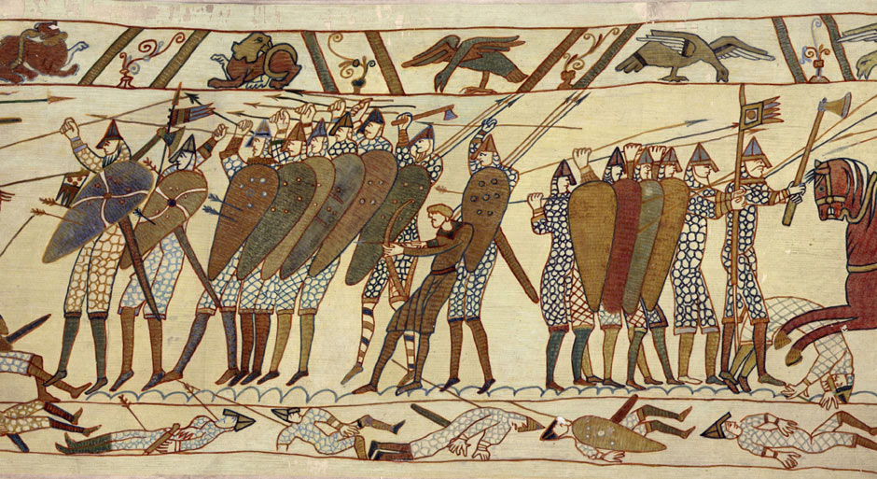
………….
In Central America, the Aztecs were busy with pictorial stories of their own., using images to represent stories of deities and wars.

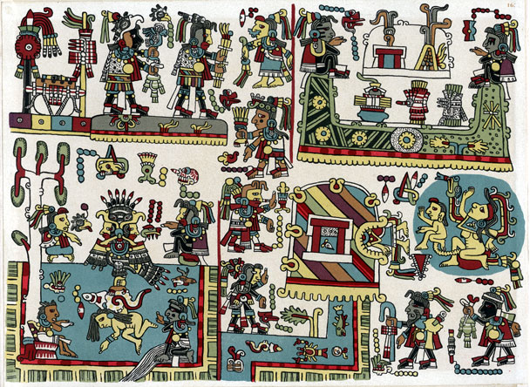

The Nuttall Codex is named after Zelia Nuttall, the scholar who identified and published it. The Nuttall Codex is painted on both sides of a prepared deerskin. Some scholars believe that it was written in the decades just prior to the Spanish conquest. The front side, consisting of 52 painted leaves, describes the origins of the Mixtec ruling families and the culture's early history. An interesting feature of the Nuttall is that it depicts representations of women, nearly all of them portrayed in responsible positions.
Among the significant historical figures recorded on the front side of the codex is Lady 3-Flint; the first two leaves of her account are shown above. Leaves 14-22 depict significant events in her life, including her progress through the priesthood to the high rank of Cihuacoatl (Woman Serpent). In the upper right-hand corner of leaf 14, she meets Lord 5-Flower, who is associated with celestial descent by his footsteps tracing back to a symbol representing the heavens. Next to Lady 3-Flint is her name symbol (three dots and a red-and-white narrow, pointed oval that represents a flint knife). On leaf 15 she is shown in a sacred rite, floating in water and wearing a serpent headdress. The images clearly convey a sequence of events, with lines drawn to help the reader determine the flow of the actions depicted. While not the traditional borders and gutters seen in American comics, the lines do indicate transitions from scene to scene.

………..
In Marriage à-la-mode, Hogarth satirizes the idea that the rich live virtuous lives by looking at the ugly truth behind arranged marriages. In each piece, he shows the young couple and their family and friends at their worst: engaging in affairs, drinking, gambling, and numerous other vices. While this is classical art, the sequencing of images is used to portray the passing of time and the telling of a story. Unfortunately for Hogarth, it is hard to make money selling to the wealthy stories in visual form the criticize the wealthy.
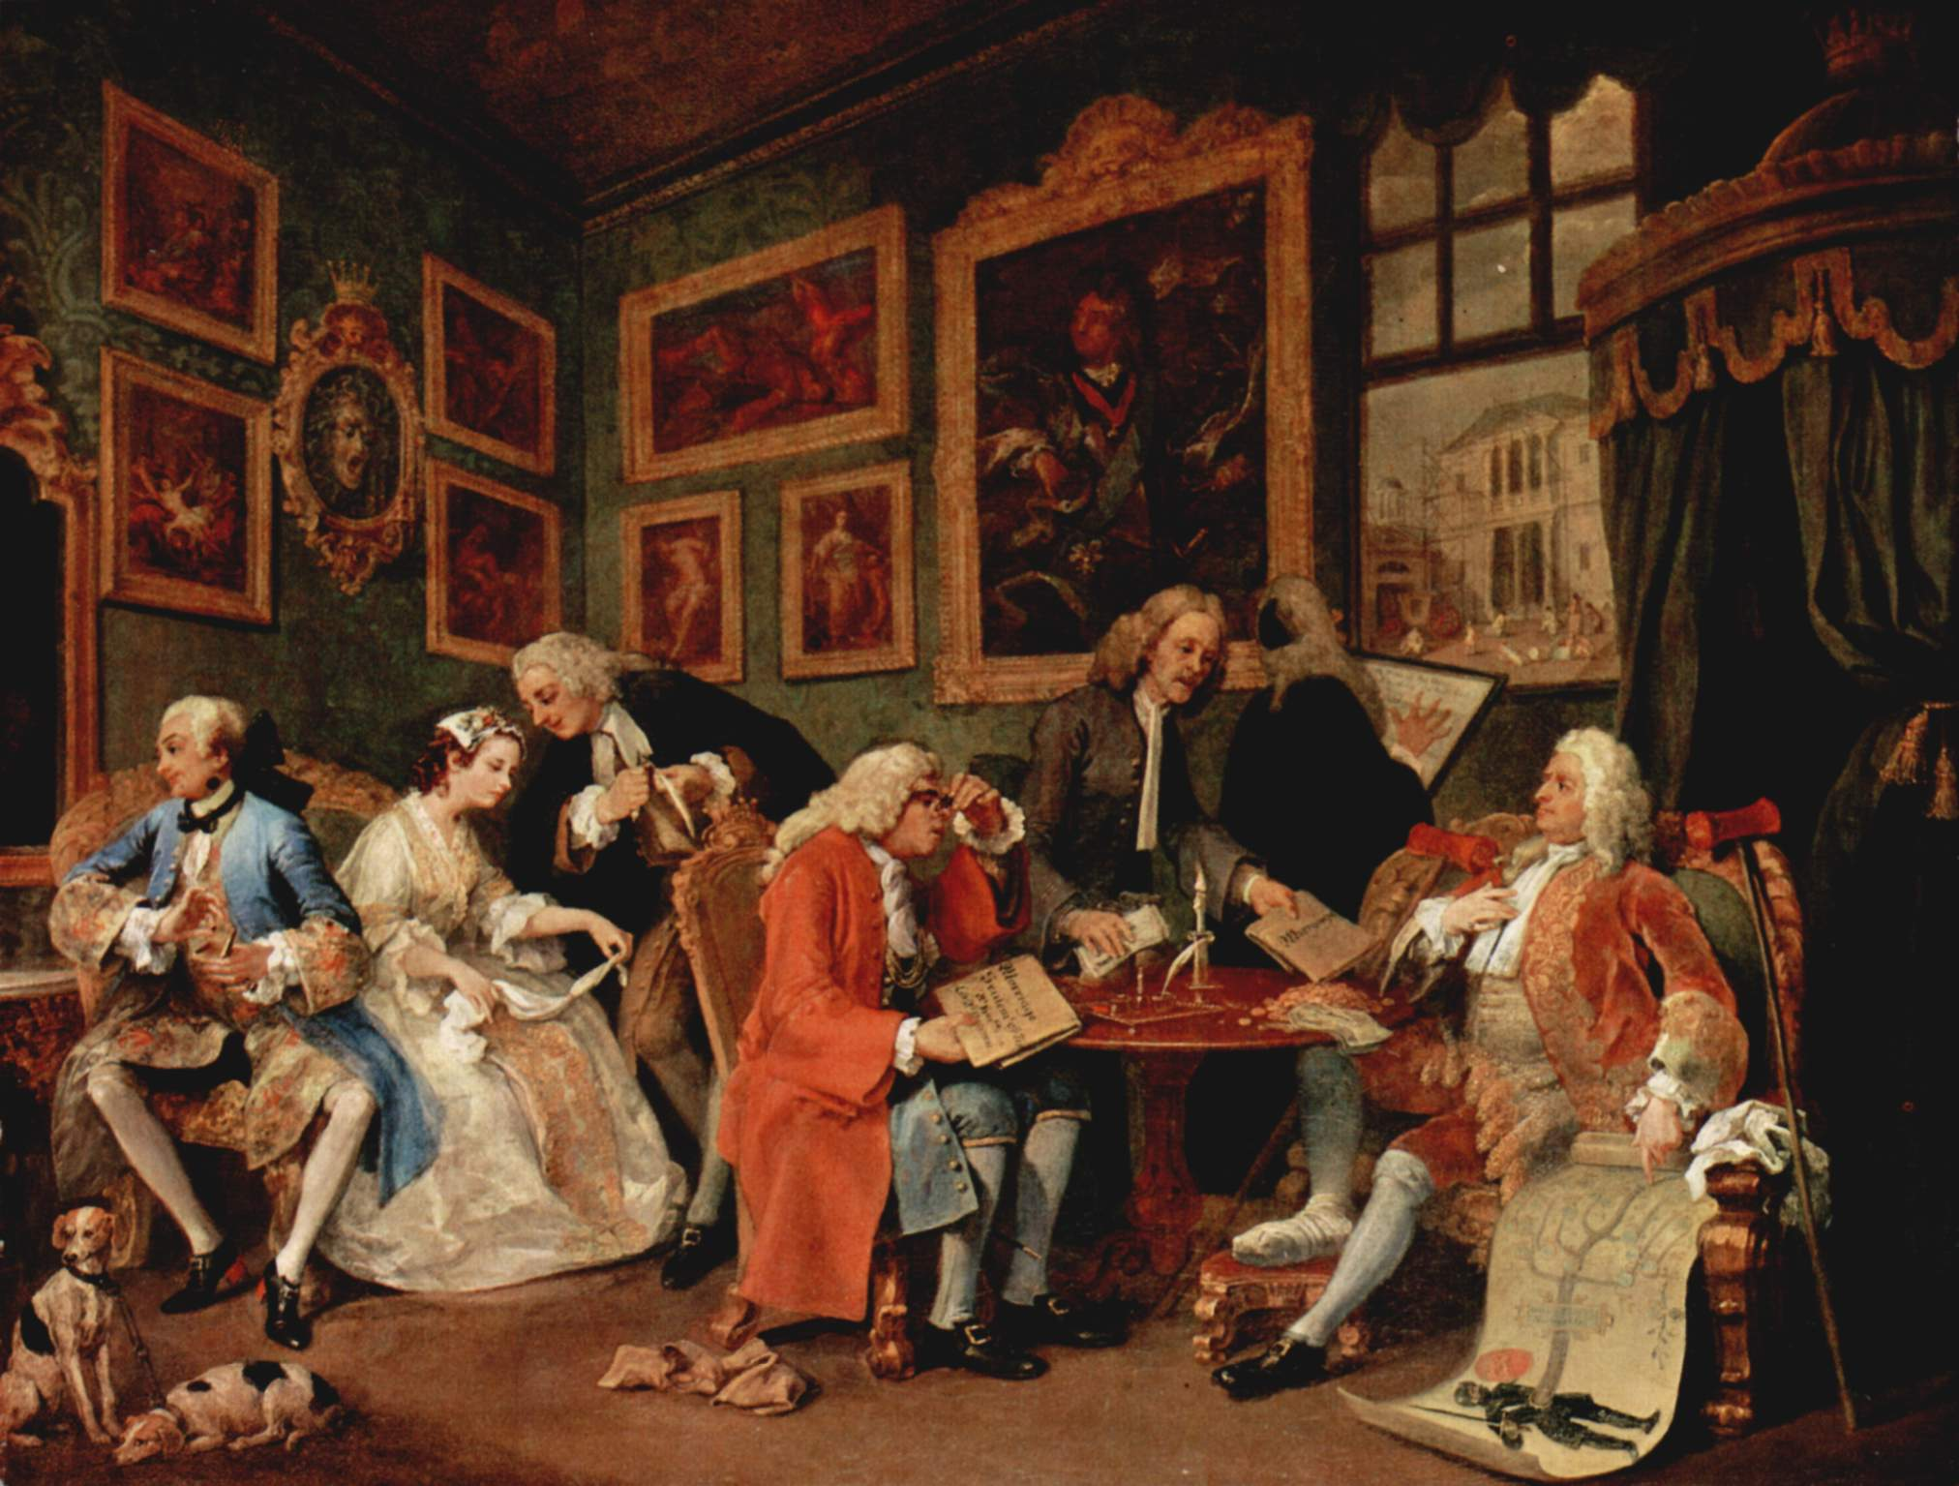
In the first of the series, The Marriage Settlement, he shows an arranged marriage between the son of bankrupt Earl Squanderfield and the daughter of a wealthy but miserly merchant. Construction on the Earl's new mansion, visible through the window, has stopped and a usurer negotiates payment at the center table. The arrogant Earl points to a picture of his family tree. The son views himself in the mirror, showing where his interests in the matter lie. The dismayed merchant's daughter is consoled by the lawyer Silvertongue while polishing her wedding ring. Even the faces on the walls appear to have misgivings. Two dogs chained to each other in the corner metaphorically symbolize the situation of the young couple.
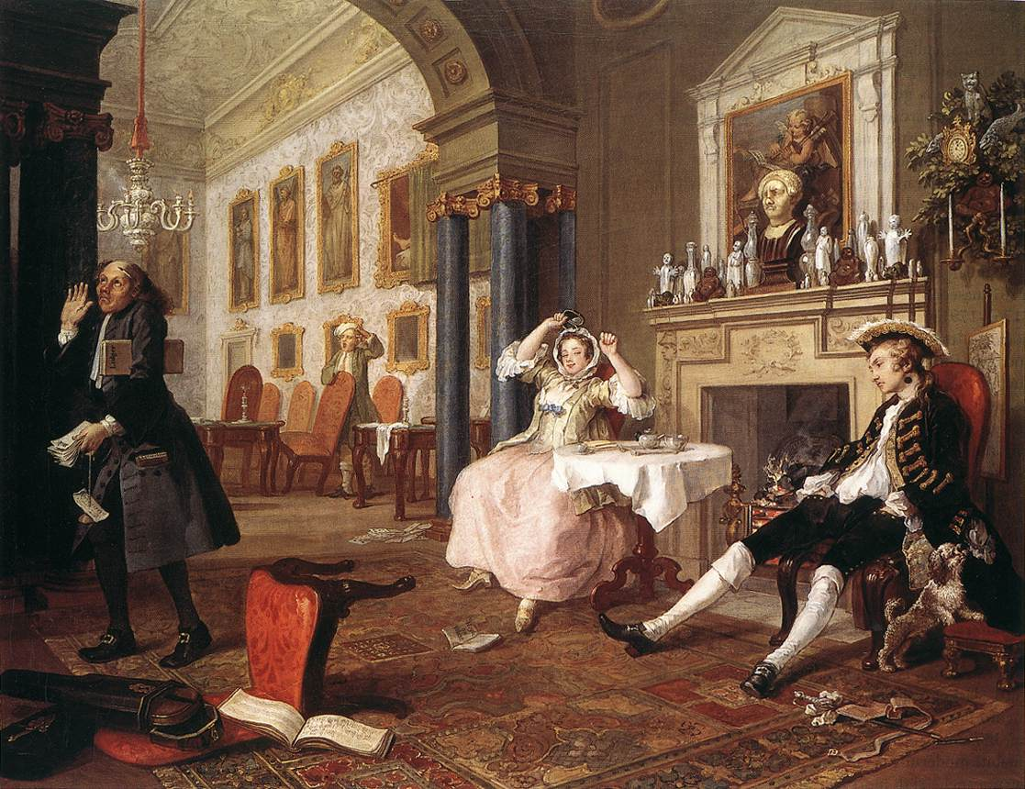
In the second, The Tête à Tête, there are signs that the marriage has already begun to break down. The husband and wife appear bored with one another, amidst evidence of their separate debaucheries from the night before. A small dog pulls a lady's hat from the husband's coat pocket, indicating his adultery. A broken sword at his feet shows that he has been in a fight. The open posture of the wife also indicates unfaithfulness. As Hogarth once noted: "A lock of hair falling thus cross the temples ... has an effect too alluring to be strictly decent, as is very well known to the loose and lowest class of women." The disarray of the house and the servant holding a stack of unpaid bills shows that the affairs of the household are a mess.
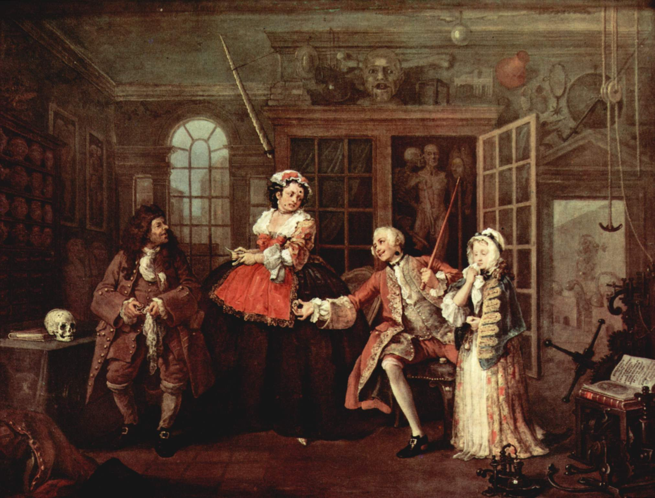
The third in the series, The Inspection, shows the Viscount visiting a quack with a child prostitute. The viscount, unhappy with the mercury pills meant to cure his syphilis, demands a refund while the young prostitute next to him dabs an open sore on her mouth, an early sign of syphilis.
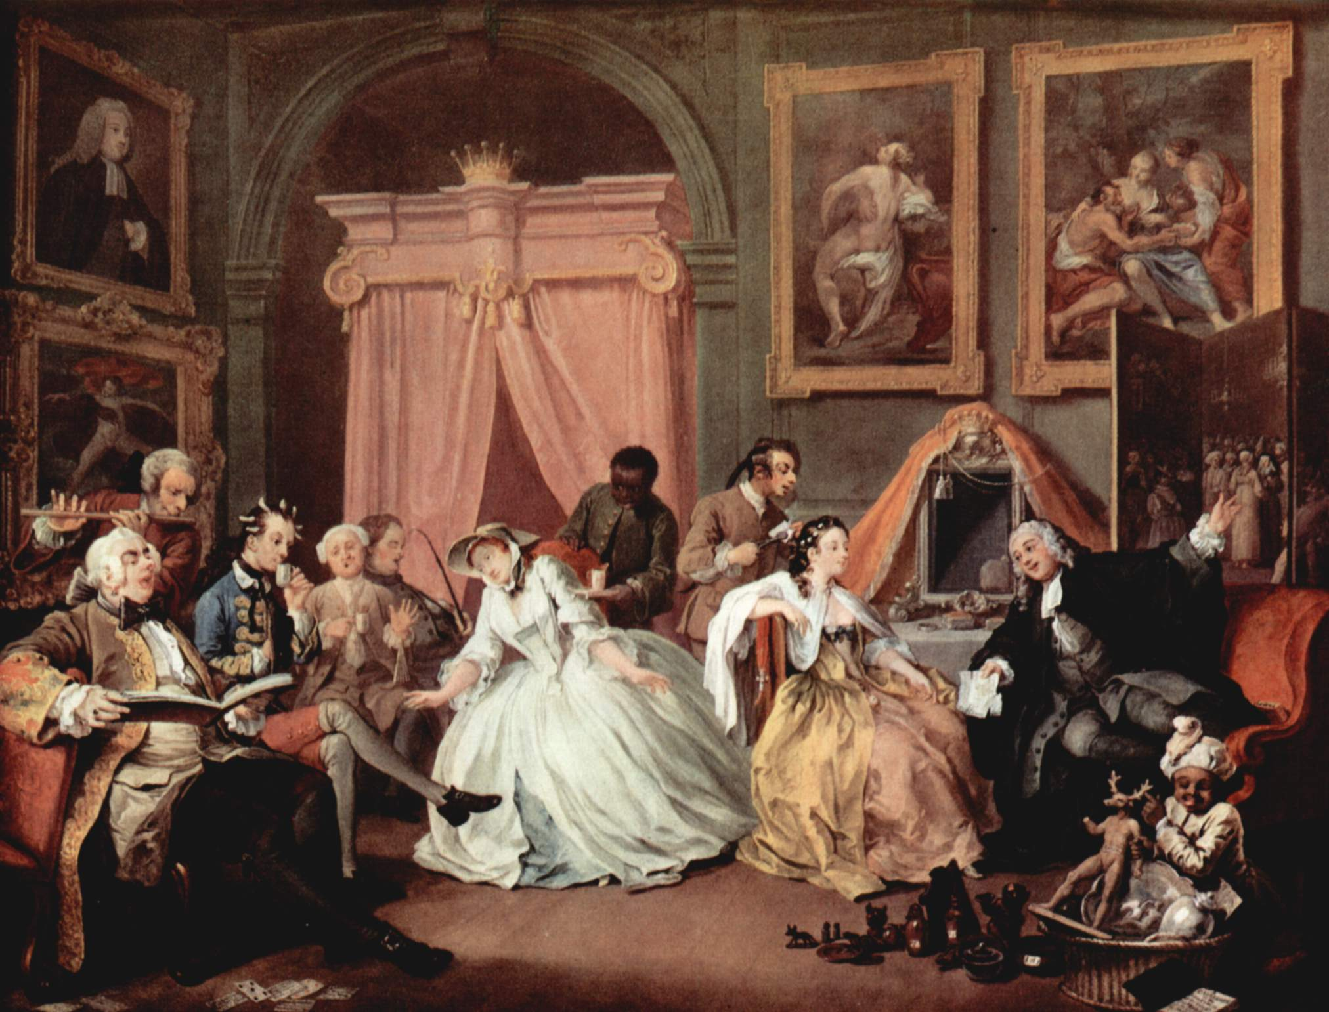
In the fourth, The Toilette, the old Earl has died and the son is now the new Earl and his wife, the Countess. The Countess sits with her back to her guests, oblivious to them, as a servant attends to her toilette. The lawyer Silvertongue from the first painting is reclining next to the Countess, suggesting the existence of an affair. This point is furthered by the child in front of the pair, pointing to the horns on the statue of Actaeon, a symbol of cuckoldry. Paintings in the background include the biblical story of Lot and his daughters, Jupiter and Io, and the rape of Ganymede.
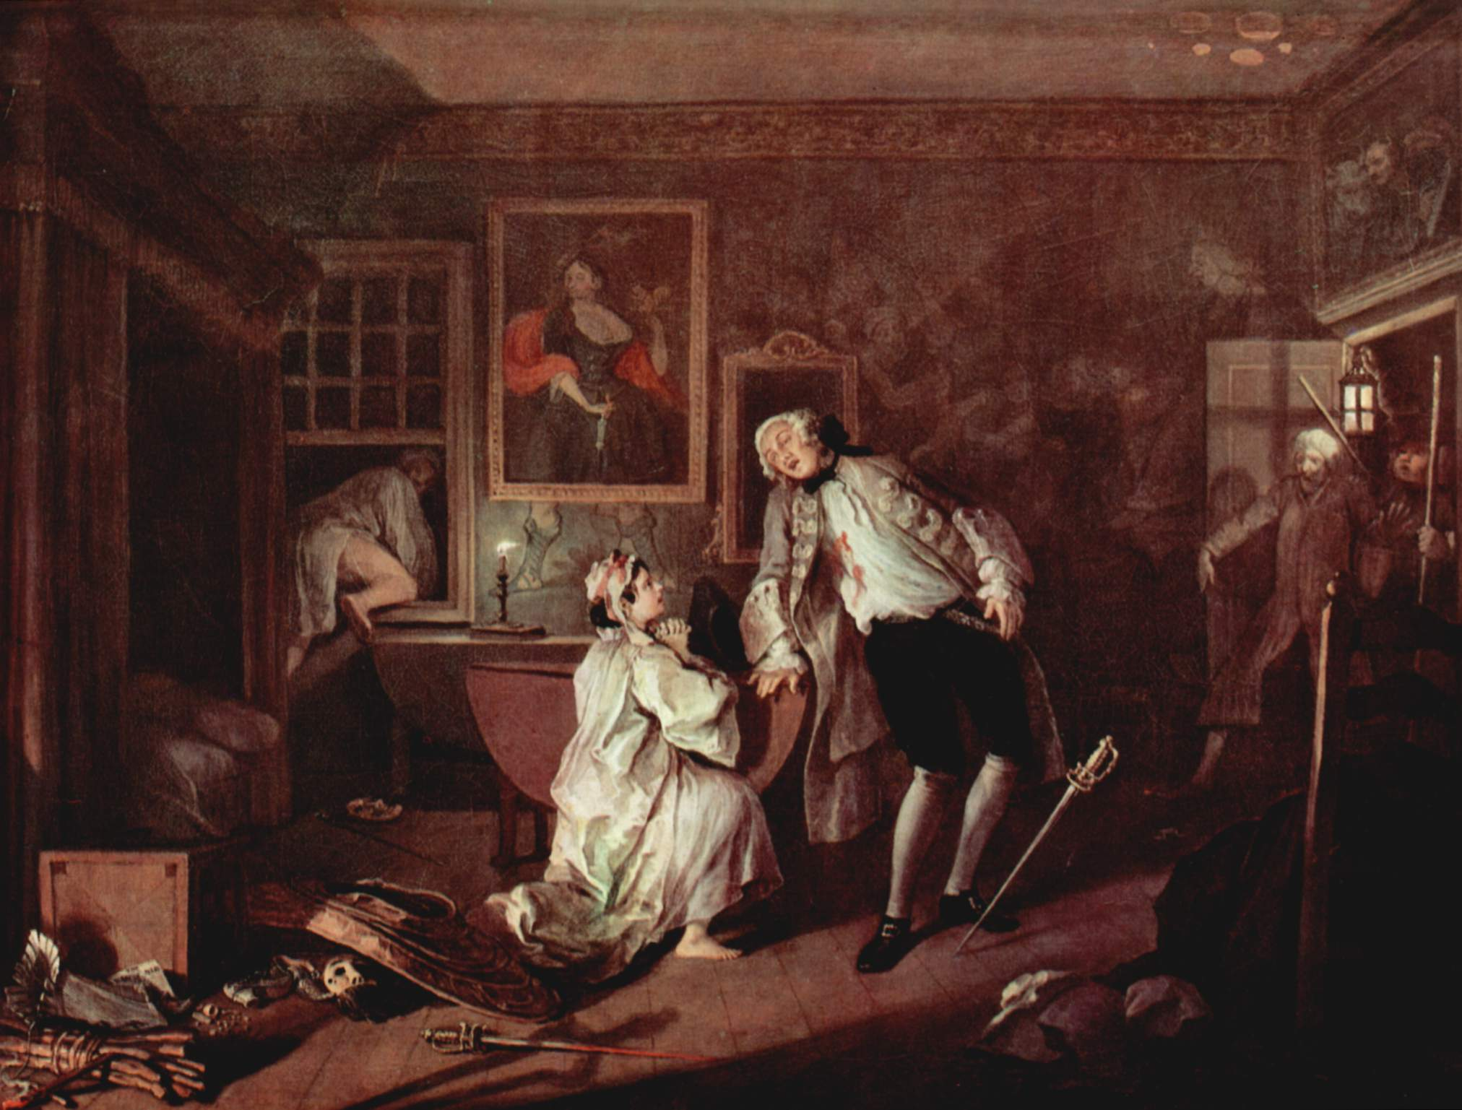
In the fifth painting, The Bagnio, the new Earl has caught his wife with her lover, the lawyer, and is fatally wounded. As she begs forgiveness from the stricken man, the murderer in his nightshirt escapes through the open window. A picture of a woman with a squirrel on her hand hanging behind the countess contains lewd undertones, as does the exposed skin of her breasts in a conservative era.
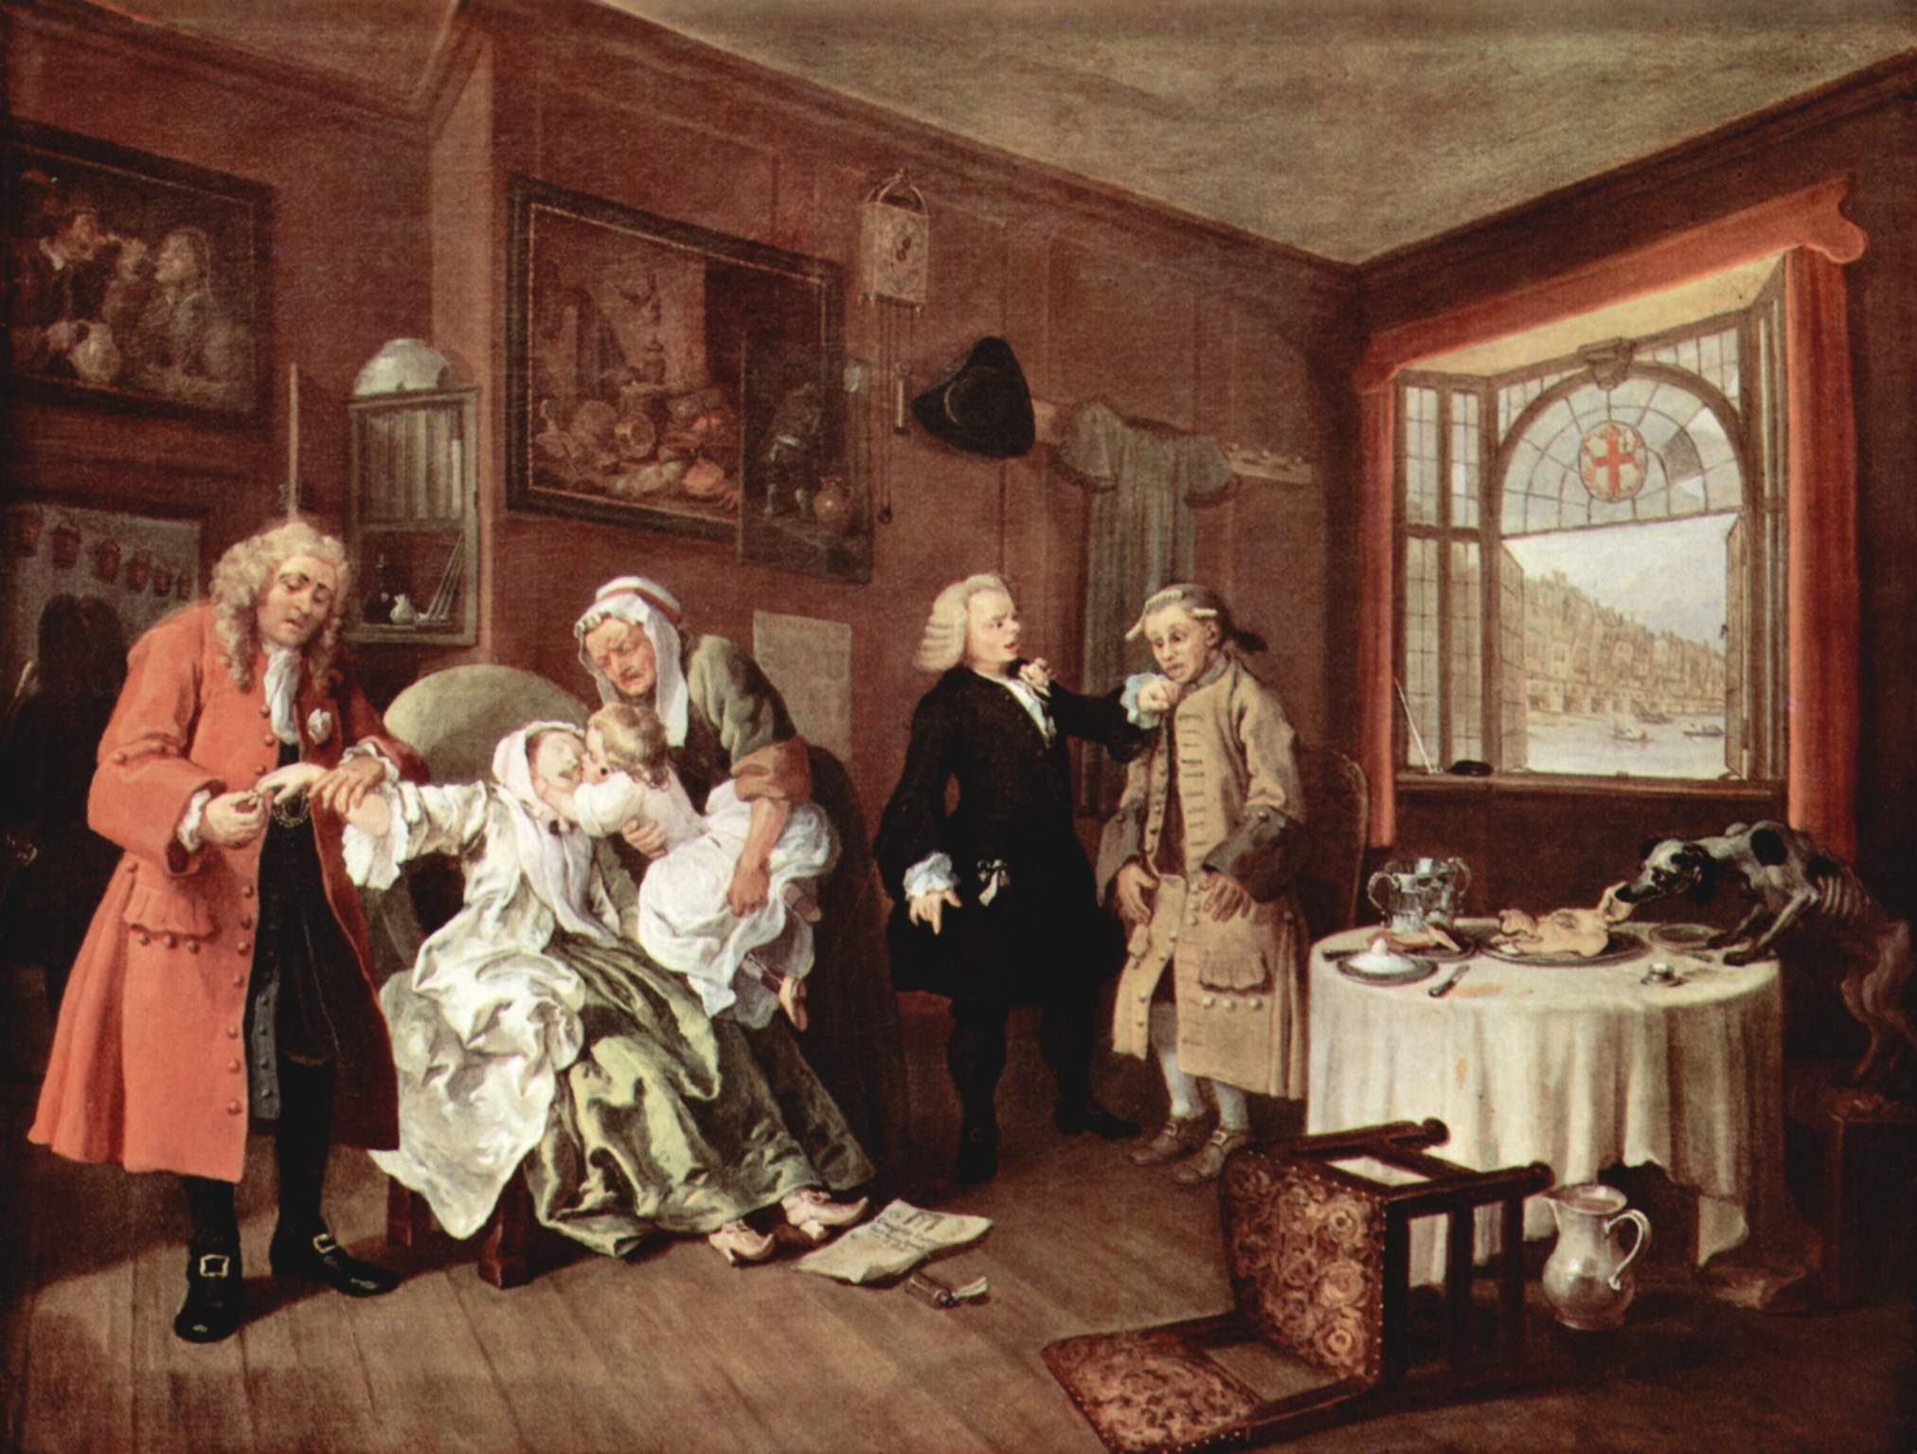
Finally, in the sixth painting, The Lady's Death, the Countess poisons herself in her grief and poverty-stricken widowhood, after her lover is hanged at Tyburn for murdering her husband. An old woman carrying her baby allows the child to give her a kiss, but the mark on the child's cheek and the caliper on her leg suggest that disease has been passed onto the next generation. The countess's father, whose miserly lifestyle is evident in the bare house, removes the wedding ring from her finger.

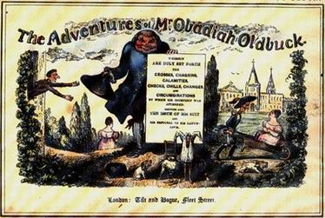
Today the earliest known comic book is called The Adventures of Obadiah Oldbuck. Originally published in several languages in Europe in 1837, among them an English version designed for Britain in 1941. A year later that version was reprinted in New York on Sept. 14, 1842 for Americans, making it the first comic book printed in America. Odadiah Oldbuck is 40 pages long and measured 8 ½" x 11". The book was side stitched, and inside there were 6 to 12 panels per page. No word balloons, but there is text under the panels to describe the story.
The comic was done by Switzerland's Rudolphe Töpffer, who has been considered in Europe (and starting to become here in America) as the creator of the picture story. He created the comic strip in 1827 and the comic book/graphic novel.

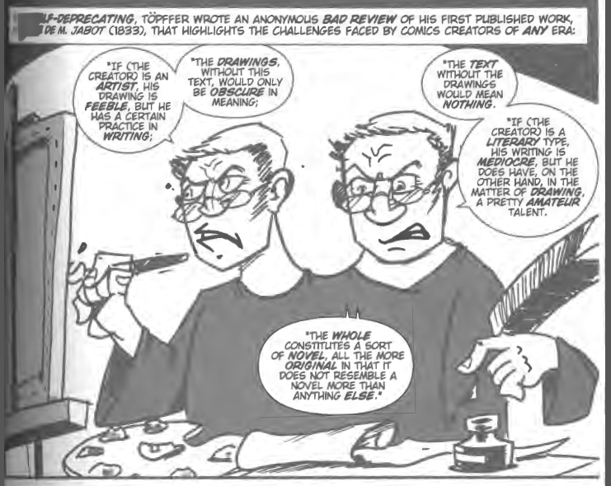
Rudolphe Töpffer created several (7 known) graphic novels that were extremely successful and reprinted in many different languages, several of them had English versions in America in 1846. The books remained in print in America until 1877.
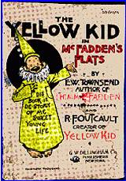
Early 1897 a book called The Yellow Kid in McFadden's Flats came out. The comic was 196 pages long, square bound, black and white, 50 cents and 5 ½" x 7 ½". It was published by G. W. Dillingham Company with permission from Hearst, the newspaper that had Hogan's Alley at the time. It was a part of a series that Dillingham did on American Authors, only he took special liberties with this one and created what is today known as a comic book.
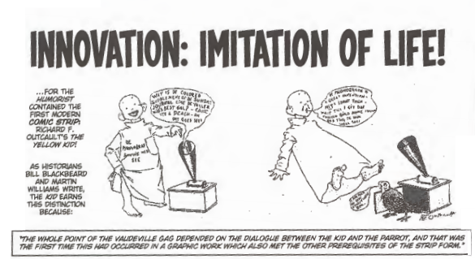
In fact this comic that coined the phrase "Comic Book" as it's written on the back cover. 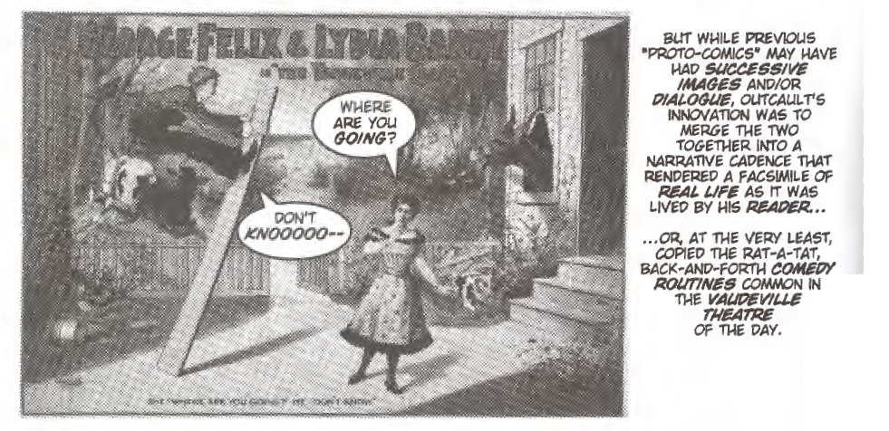
This comic book starts what is now called the Platinum Age of Comics, and mirrors some of the developments of the film industry in it’s infancy, including the tendency to model the setting within the context of a stage based background.
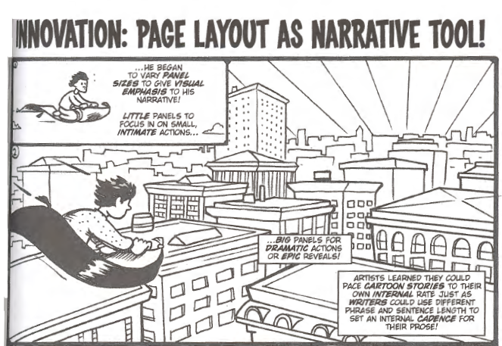
McCay developed the techique of varying the size of the panels in 1912, In film, this was frequently known as the establishing shot, usually a panoramic scene.
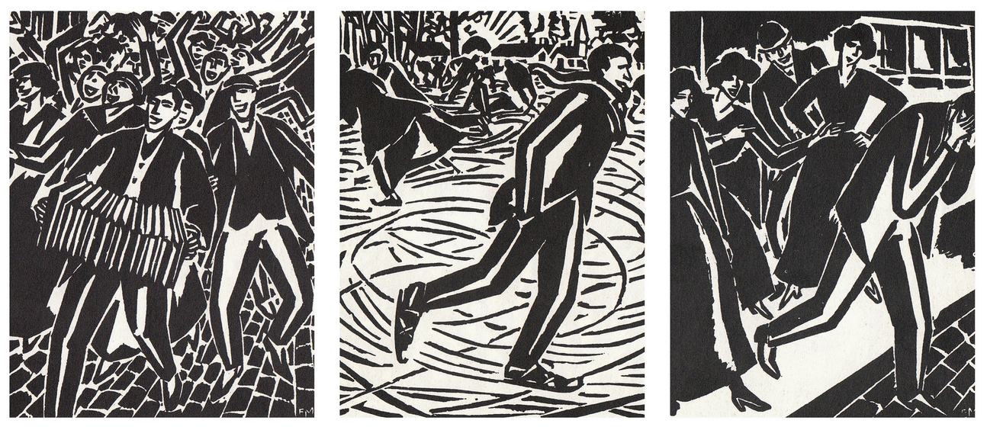
Toeffler intended his satires to amuse a sophisticated elite. However, the next generation of story tellers from Europe found inspiration in the stark class struggles of the early 20th century. Flemish illustrator Frans Masereel perfected his blocky black and white newspaper spot art style using woodcuts to create a wordless “novel” of one panel per page. His most famous work was known in English as Passionate Journey. The 167 page account of a young man;s rebellion against society was done completely with woodcuts.
American art student Lynd Ward discovered Masreel’s woodcuts while studying print making in Europe. Inspired, he created a woodcut story of a aspiring artist who makes a suoernatural bargain for success.
Why was the woodcut popular?
The woodblock, whether cut with a knife or engraved, achieves it’s effect by bringing darkness into light.
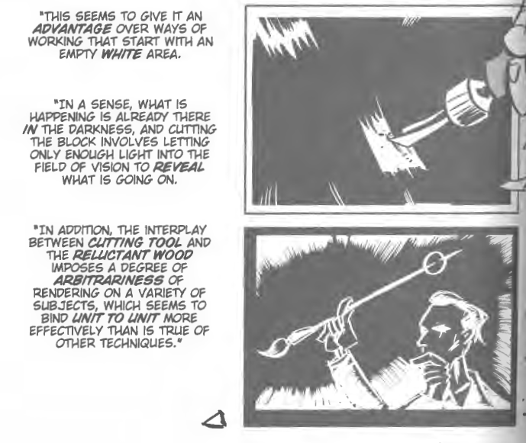

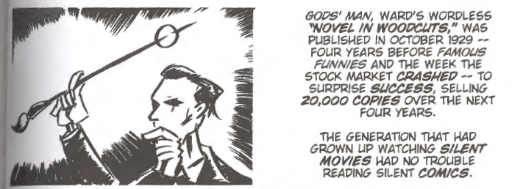

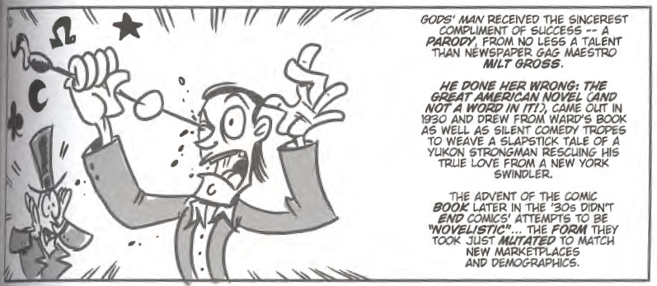

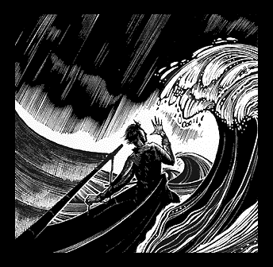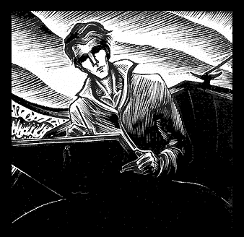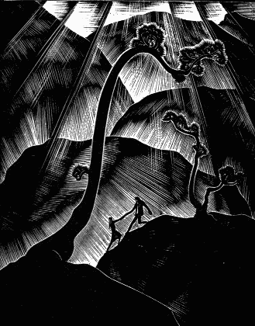
Influenced by the silent movies of the era, Lynd Ward produced woodcut novels entirely without text, but which effectively conveyed a story. One of his most famous works was God’s Man, produced in 1929. In God’s Man, of a suffering young artist who sells his soul to the devil, with predicable consequences.
The Platinum Age 1897 - 1938
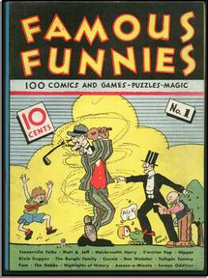
http://www.diamondcomics.com/bookshelf/a_history_of_comics.htm
While some will argue that “comics” as an artform predate the 1930s, the fact is that such comics resemble a modern comic book, but are not precisely the same. Let the scholars and academics argue the semantics of “what is a comic?” For all intents and purposes, the first publication that would be recognizable to a modern audience was published in 1934: Famous Funnies #1 (dated July).
http://www.collectortimes.com/~comichistory/frames.html
In May 1934 (the comic was dated July), another first issue of Famous Funnies appeared on the newsstands. It featured four pages each of several newspaper comic characters. It was 64 pages long but kept the 10 cent price tag. It had a 90% sell though but still lost $4,150.60. A second issue came out in July (cover dated September) and was monthly after that. With the second issue the magazine hired people at 5 dollars a page to create original material for them. Meanwhile it cost the magazine 10 dollars a page for Syndicated reprints. The comic was edited by Steven O. Douglass but Moore got the credit in the first issue. From issue #3 and on Buck Rogers took the center stage and became the comics feature character. By 7th issue, finally a profit emerged as the group made $2,664.25, but it must have been too little, too late as Dell Publishing got cold feat and sold their 50% to Eastern Color. Still, every issue had higher sales, and by a years time sales were up to almost a million per month. How the 10 cents per issue got divided among the parties bounced around as the series progressed. At first Eastern would see 6 of the 10 cents, later it was 6 ½. The rest was split between Newsstand and Distributor with the newsstand taking 2 then 2 ½ cents and American News took 1 then 1 ½ cents. Eastern proudly made public the amount of money they were making off the comics, as a way of saying "I told you so" to the many people rejected the idea at first. They were making $30,000 per issue. They also did this to drum up more business, either as a publisher or printer. By the time a year had gone by Funnies had gained some respect and was placed on newsstands beside slick magazines like Atlantic Monthly and Harper's. They also had 5 competitors putting out monthly magazines. This comic series would last 218 issues ending in 1955
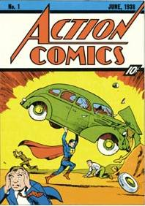
http://theages.superman.ws/History/VersionI.php
In Action Comics #1, a one page origin of Superman is given. This was expanded to two pages for Superman #1, which also featured four additional pages tacked on to the beginning of Superman's first adventure. Both of these versions are abridgements of the story as actually written by Jerome Siegel and Joseph Shuster in the early '30s. That version had initially been prepared in 1934 as a newspaper comic strip and submitted to syndicate after syndicate collecting rejections. The tale had been rewritten and recut several times, with no version achieving much success.
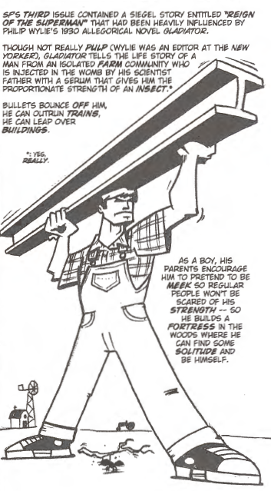
Unable to sell the strip anywhere, Siegel and Shuster used concepts from it in strips they were handling for DC Comics, notably "Federal Men" and "Dr. Occult." In these features, a man named Jor-L and the classic red-and-blue tights first appeared. Success for Superman himself finally occurred when M.C. Gaines bought the feature for a new comic he was packaging, the now famous Action #1. The newspaper adventure strip was cut up and reassembled into comic book pages. Presumably, Gaines thought the story was too long, or perhaps too slow moving for his readers, so the origin sequence was severely truncated.

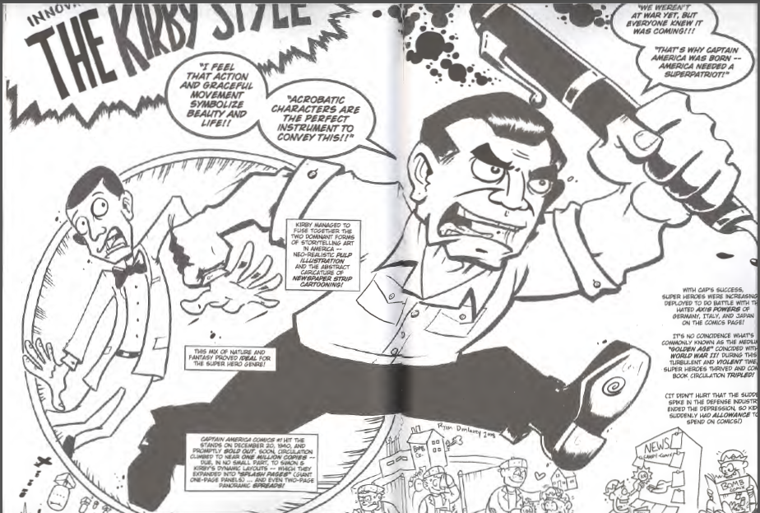
The Golden Age (1938 - 1956)
Meanwhile, over at Timely Comics, Jack Kurtzwell was developing the visual style that he would be noted for in the later Marvel comic years, when he took the pen name Jack Kirby. His Captain America comic actually fought Axis powers, and was very popular with both the troops and the kids back home.
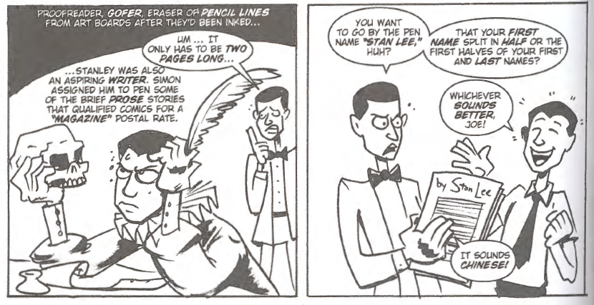
Unfortunately for Jack (Kirby) Kurtzwell, in his new office, he had to put up with the flute playing young cousin of the owners. Stanley Lieber later became the architect of Marvel comics success (although he had several disputes with his artists) as the writer editor Stan Lee.
Disney followed up on his popular, if not always financial success.
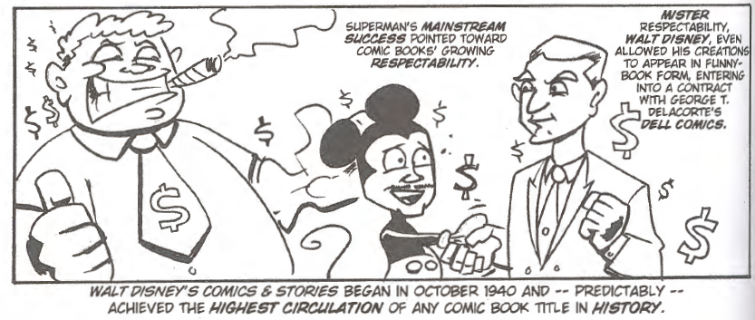
…………………..
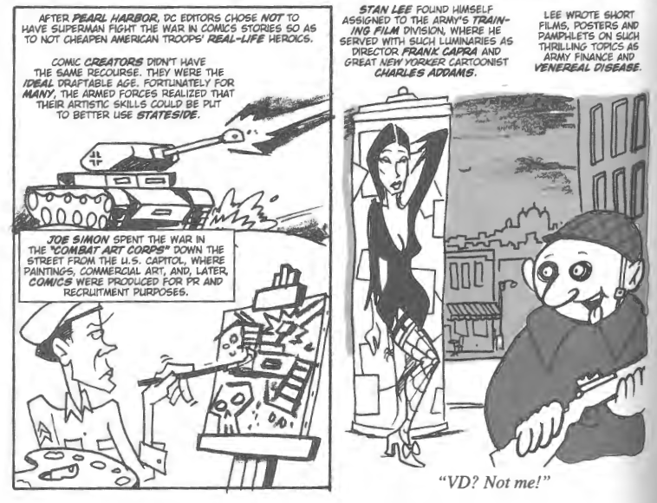

Joe Simon of Superman fame was drafted, and spent the war in the Combat Art Corps in Washington DC, while Stan Lee received his introduction to short film making, producing instructional videos.
Comics were taking a more serious form, with the help of Classics Illustrated, founded in 1941.
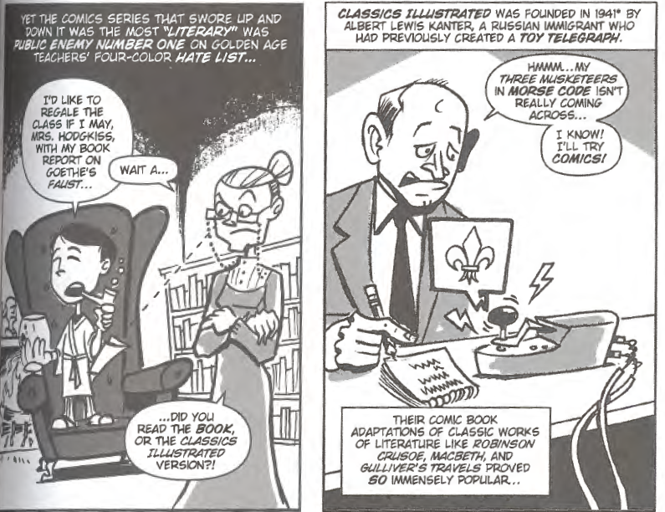

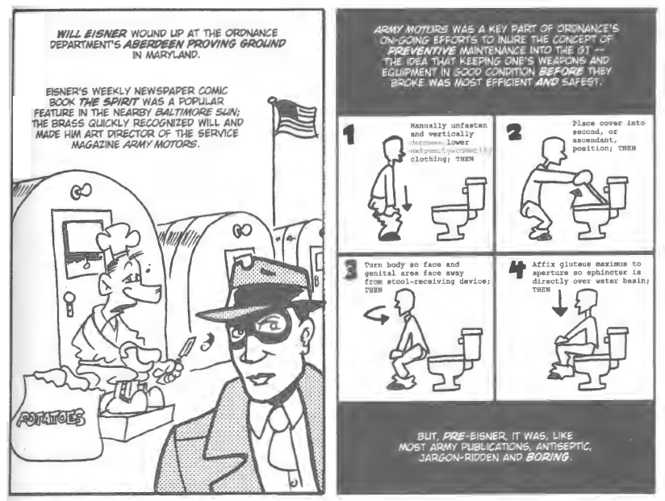
Will Eisner, who would make his mark in many ways in the comic world as the creator of the Spirit comic book and originator of the graphic novel, also made is mark on the war effort with the creation of more ENGAGING instructional manuels.

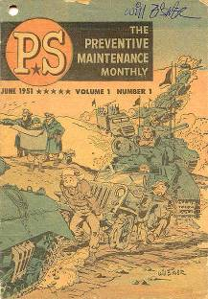

http://ieeexplore.ieee.org/iel1/47/4514/00180282.pdf?arnumber=180282
The Army has long recognized the need for visually dynamic training materials. They are accustomed to working with soldiers who need to maintain and operate complex machines, but who may have poor reading and attention skills.

http://www.army.mil/soldiers/jun2001/features/psmag.html
Note: The two main characters, MSG Half-Mast and Connie Rodd, have appeared in every issue and were created by Will Eisner.

http://en.wikipedia.org/wiki/Will_Eisner
During his World War II military service, Eisner had introduced the use of comics for training personnel, in the publication Army Motors, for which he created the cautionary bumbling soldier Joe Dope, who illustrated various methods of preventative maintenance of various military equipment and weapons. In 1948, while continuing to do The Spirit and seeing television and other post-war trends eat at newspapers' readership base, he formed the American Visuals Corporation in order to produce instructional materials for the government, related agencies, and businesses. One of his longest-running jobs was P*S: The Preventive Maintenance Monthly, a digest-sized magazine with comic-book elements that he started for the Army in 1951 (during the Korean War) and continued to work on until the 1970s with Mike Ploog and other artists

http://www.olive-drab.com/archive/ps_50yrs_pm.pdf
The concept of PS actually began in World War II with Army Motors, the Army’s first maintenance magazine. It was in Army Motors that PS’ two most prominent characters, MSG Half-Mast and Connie Rodd, first appeared.

Will Eisner, "Comic Books in the Library. » School Library Journal, Oct. 1974: 75-79.
"During World War II, the need for instantly trained mechanics, gunsmiths, equipment operators and other specialists and the availability of trained sequence-picture artists were joined. Introduced early in the war by the Pentagon, instructional materials in comic book format were published about military courtesy and the care and maintenance of equipment--everything from how-to-do-it to preventative maintenance,"

http://www.army.mil/Soldiers/jun2001/pdfs/psmag.pdf
The Golden Age of comics did not last forever. Along with the paranoia and fear of communists in government, there was concern about the content and negative influence of comic books.
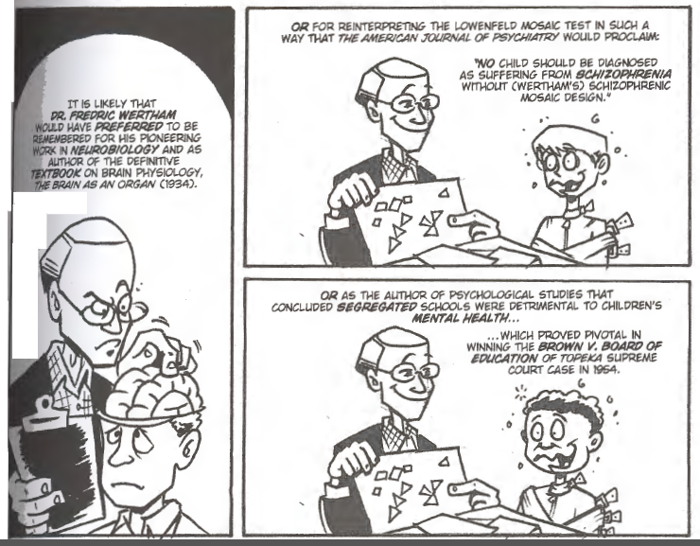
Leading the attack was Dr. Fredrick Wertham.

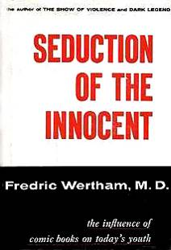

http://en.wikipedia.org/wiki/Seduction_of_the_Innocent
Seduction of the Innocent was a book by Dr. Fredric Wertham, published in 1954, that warned that comic books were a bad form of popular literature and a serious cause of juvenile delinquency. The book was a minor bestseller that created alarm in parents and galvanized them to campaign for censorship. At the same time, a U.S. Congressional inquiry was launched into the comic book industry, and the Comics Code Authority was voluntarily established by publishers to self-censor their titles.
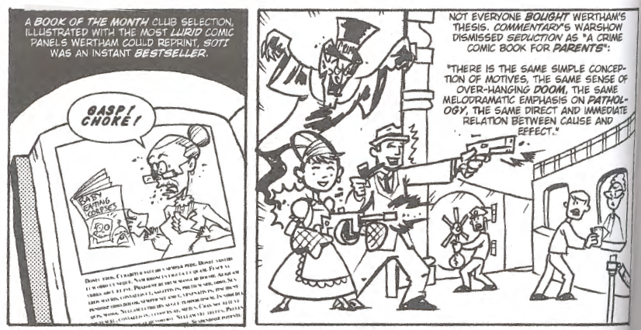
Seduction of the Innocent cited overt or covert depictions of violence, sex, drug use, and other adult fare within "crime comics"—a term Wertham used to describe not only the popular gangster/murder-oriented titles of the time, but superhero and horror comics as well. The book asserted, largely based on undocumented anecdotes, that reading this material encouraged similar behavior in children.
Comics, especially the crime/horror titles pioneered by EC, were not lacking in gruesome images; Wertham reproduced these extensively, pointing out what he saw as recurring morbid themes such as "injury to the eye". Many of his other conjectures, particularly about hidden sexual themes (e.g. images of female nudity concealed in drawings of muscles and tree bark, or Batman and Robin as homosexual lovers), were met with derision within the comics industry. (Wertham's claim that Wonder Woman had a bondage subtext was somewhat better documented, as her creator William Moulton Marston had admitted as much; however, Wertham also claimed Wonder Woman's strength and independence made her a lesbian.)
The splash made by this book, and Wertham's previous credentials as an expert witness, made it inevitable that he would appear before the Senate Subcommittee on Juvenile Delinquency led by anti-crime crusader Estes Kefauver. In extensive testimony before the committee, Wertham restated arguments from his book and pointed to comics as a major cause of juvenile crime. The committee's questioning of their next witness, EC publisher William Gaines, focused on violent scenes of the type Wertham had decried. Though the committee's final report did not blame comics for crime, it recommended that the comics industry tone down its content voluntarily. Possibly taking this as a veiled threat of potential censorship, publishers developed the Comics Code Authority to censor their own content. The Code not only banned violent images, but entire words and concepts (e.g. "terror" and "zombies"), and dictated that criminals must always be punished. This destroyed most EC-style titles, and leaving a sanitized subset of superhero comics as the chief remaining genre. Wertham nevertheless considered the Comics Code inadequate to protect youth.
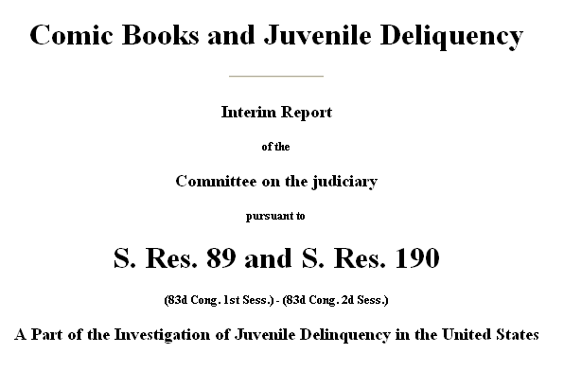
http://www.geocities.com/Athens/8580/Hist2.html#senate
http://www.geocities.com/Athens/8580/kefauver.html
Seduction of the Innocent caused a U.S. Senate Investigation into the relationship between comic books and juvenile delinquents. Dr. Wertham was called to testify at the hearings, as were other juvenile delinquent experts, representatives of the major comic companies, some of their advertisers and distributors, and the representatives from National Cartoonist Society.
Dr. Wertham came out on top. He had a lot of experience testifying in front of government committees (read his biography for more information). Most of the representatives from the comic companies were business men who knew very little about the editorial content of the comic books, so their answers about those topics were vague and seemed evasive. But they did know about the complex workings of their companies, and for that reason they were sent. The one exception to this was William Gaines, publisher of E.C. (who published most of the horror comics). William Gaines had a teaching degree, and was able to answer the questions clearly and state his side rather well. The National Cartoonist Society representatives, Walt Kelly, Milton Caniff, and Joe Musial all distanced themselves from comic books and gave a general condemnation of them (traitors!).
The result of these hearings was the Senate committee advised comic companies that "A competent job of self-policing within the industry will achieve much."

http://www.geocities.com/Athens/8580/Hist2.html#senate
http://en.wikipedia.org/wiki/Comics_Code_Authority
The Comics Code Authority (CCA) is an organization established to regulate the content of comic books in the United States. Member publishers submit comic books to the CCA, which screens them for conformance to its Comic Code, and authorizes the use of their seal on the cover if the books comply. At the height of its influence, it was a de facto censor for the U.S. comic book industry.
The CCA was founded in 1954, in response to public concern about what was deemed inappropriate material in many comic books. This included graphic depictions of violence or gore in crime and horror comics, as well as the sexual innuendo of what aficionados refer to as good girl art. Dr. Fredric Wertham's book Seduction of the Innocent rallied opposition to this type of material in comics, arguing that it was harmful to the children who made up a large segment of the comic book audience. Senate subcommittee hearings led by Estes Kefauver had many publishers concerned about government regulation, prompting them to form a self-regulatory body instead.
In its original form, the Code prohibited depictions of gore, sexuality, and excessive violence; required that authority figures were never to be ridiculed or presented disrespectfully, and that good must always win; and prohibited scenes with vampires, werewolves, ghouls or zombies. The code also prohibited advertisements of liquor, tobacco, knives, fireworks, nude pin-ups and postcards, and "toiletry products of questionable nature".
There were critics from both sides of the debate. Wertham dismissed the Code as an inadequate half-measure. William Gaines, head of EC Comics — whose best-selling titles included Crime SuspenStories, The Vault of Horror and The Crypt of Terror — complained about clauses prohibiting titles with the words "Terror", "Horror", or "Crime", as well as the clause banning vampires, werewolves, and zombies. Indeed, these restrictions quickly made EC unprofitable, and all its comics besides MAD were dropped within brief years following the CCA's introduction.
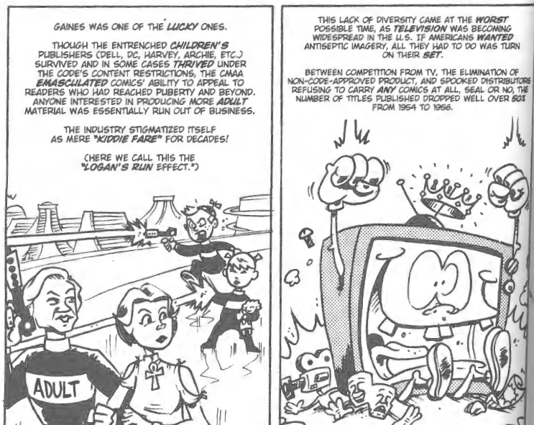
While the CCA did not have any legal authority over other publishers, magazine distributors often refused to carry comics without the CCA's seal of approval. Some publishers thrived under these restrictions, others adapted by canceling unapproved publications and focusing on Code-approved content, and others were unable to survive. The range of comics published contracted substantially following the introduction of the Code. Older readers abandoned the medium, dissatisfied by stories written within parameters intended to make them suitable for children. The medium came to be even more strongly associated with children, a perception that persists to this day.
Comics Magazine Association of America Comics Code 1989
http://www.collectortimes.com/~comichistory/cca3.html
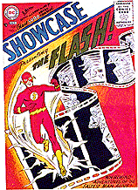
http://www.collectortimes.com/~comichistory/frames.html
The Silver Age of Comics begins, as characters based on popular Golden Age heroes are updated and refurbished for a new generation of readers. It all started with Showcase #4, starring The Flash. This Flash was a revamped version of the Golden Age Flash, he was created by Julius Schwartz and Carmine Infantino. After a few appearances in Showcase comics, The Flash received his own title. The success of The Flash caused other golden-age heroes to come back, although revamped like The Flash. In short, The Flash became a hero on two fronts, first in the comic book, and second in the comic industry. Bringing back The Flash brought superheroes back into the mainstream, and changed the comic industry to this day. This includes other superhero comic books, their T.V. shows, movies, and anything else they might have inspired.

Stan Lee produced Marvel Comics hit, The Fantastic Four, in much the same way as he produced his monster books. Lee is quoted, "I wrote an outline containing a basic description of the new characters and the somewhat offbeat story line and gave it to my most trusted and dependable artist, the incredibly talented Jack Kirby.
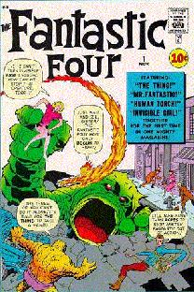
http://www.collectortimes.com/~comichistory/frames.html
The Marvel Age started in 1961, when Marvel Comics started to put out it's own superheroes. The very first superhero book that Marvel produced was Amazing Adventures #1 which had a character named Dr. Droom (not 'Doom'). This character didn't work out so well, but Marvel did keep putting out other superheroes. Dr. Droom was later revamped and brought back as Dr. Druid. Some of the original concept ideas for the abilities of the Fantastic Four were not too good, either.
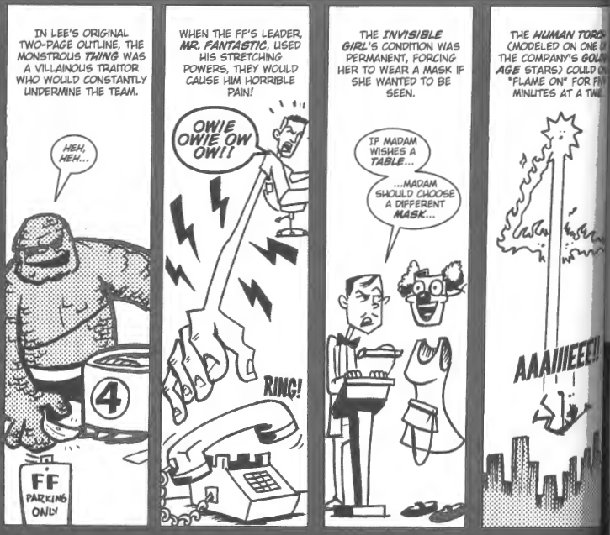
The very first superhero team book Marvel put out was Fantastic Four #1, which also came out in 1961. In DC all the characters in a team got along just fine and there were no problems between them. But not in this book! A particular member of the Fantastic Four was Ben Grimm, A.K.A. The Thing. This character has a horror-style feel to him. He truly was his name, a thing, a monster who scared people when they looked at him.
Characterized by surprisingly fallible superheroes who led relatively normal lives filled with real-world trials and tribulations.
The Fantastic Four comics were labeled "The Worlds Greatest Comic Magazine". It's a brave title, but one they lived up to. The Fantastic Four comic made many changes to the comic industry. Much of them was with their outerspace stories, but some of them were right at home on earth. One of them was allowing heroes to get married. In the Fantastic Four Annual #3 (1965), two of the main characters, Reed Richards and Susan Storm got married. This was a big change from the times when the hero wouldn't even kiss the girl. But they went further than that. 3 years later Reed and Sue had a baby. In Fantastic Four Annual #6 (1968) Franklin Richards was born. Through out the comic, and even today, we see this Superhero team have to go through the unique troubles of raising a superpowered child while living a life of adventure. In the 1960s, art was embraced, and Stan Lee was considered a very popular artist.
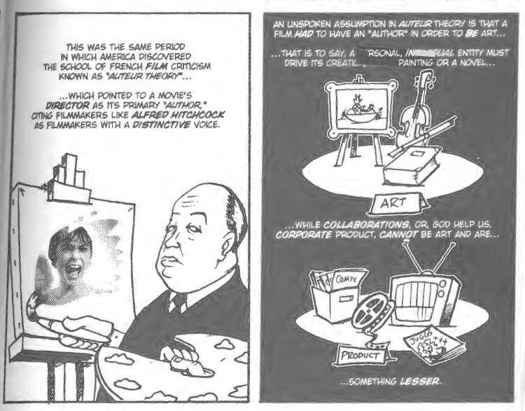
…..
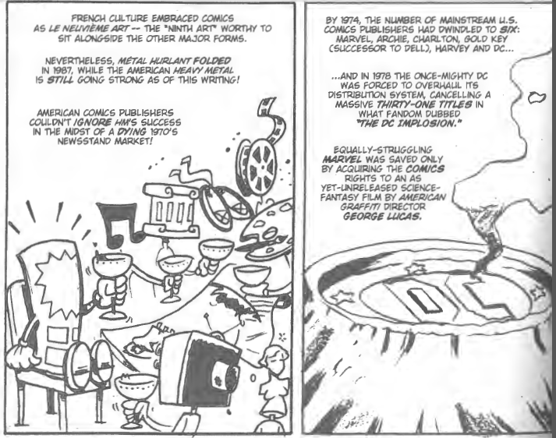
……
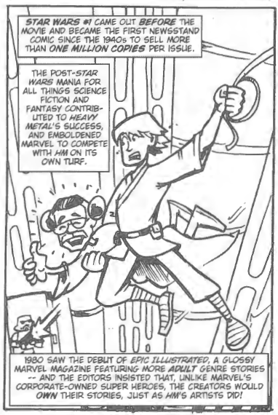
…..
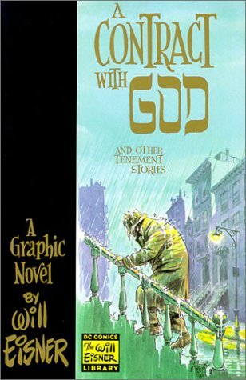
Eisner, Will. A Contract With God and Other Tenement Stories . New York: DC Comics, 1978.
This is the work that is largely considered to be the first graphic novel, and it is also one of the best. Eisner calls on his memory of growing up in New York Tenements in the early part of the 20th century to create several tales of life at one particular address. The characters in the stories are made human by their equal mix of flaw and charm, and the stories rarely end in the way you would expect. Eisner also redefines standard comic formats and conventions to create spectacular scenes that transform the written word into art itself.
Technically a collection of four short stories
The first major original graphic novel, this book weaves short stories into a longer and cohesive narrative. Eisner is a true pioneer in the comics field: He was among the first successful artists and studio operators in the 1930s. He pioneered educational and instructional comics for institutional uses in the 1940s and 1950s. In the '70s, he reinvented his career as the first comics' professional to concentrate on original graphic novels.
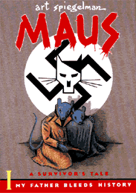
Maus I, - 1986
Spiegelman, Art. Maus: A Survivors Tale - My Father Bleeds History/And Here My Troubles Began . Random House Trade Paperbacks, 1986.
This is the graphic novel that brought mainstream attention to the medium. Art Spiegelman tells the story of his father, Vladek Spiegelman, and his experience as a Jew during the Holocaust. Although the story is true, Spiegelman decides to use anthropomorphic representations of the characters, portraying the Jews as mice and the Germans, naturally, as cats. It is fascinating double-narrative of not only Vladek Spiegelman's story, but the process that Art Spiegelman went through to get the story out of him.
Perhaps no other single work is more responsible for legitimizing comics as a serious art-form. Spiegelman's Pulitzer Prize for Maus clearly has inspired a new generation of comic artists to break away from the story-telling conventions of the medium and to move to works of deeper personal expression.
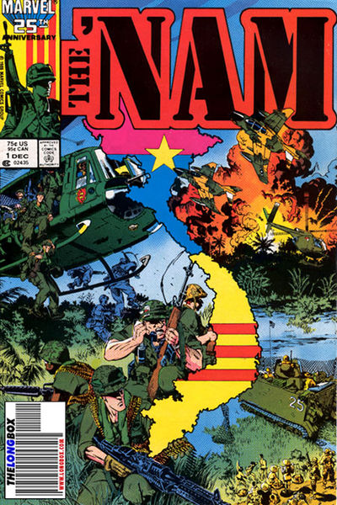
’Nam (1987), a graphic novel by Doug Murray, won the Best Media of the Vietnam War Award given by Bravo Organization
The 'Nam was an historical fiction serial published in comic book form, detailing the U.S. War in Viet Nam from the perspective of active-duty soldiers involved in the conflict. It was written by Doug Murray, illustrated by Michael Golden, and published by Marvel Comics for seven years beginning in 1986.
The comic is structured as the narrative of a fictional soldier, Private First Class Edward Marks (but sometimes following other characters), as he experiences real events that occurred during the conflict. Each issue of the comic occurs one month after the previous issue, detailing events that occurred approximately 20 years prior to the publication date.
The events depicted are sometimes famous ones, such as the Tet Offensive of 1968, and sometimes more personal ones, depicting the interaction between soldiers or between soldiers and the local populace of Viet Nam, or between soldiers and their families, friends and others in the United States.
Some of the stories are typical of those in war comics of any era, such as the interaction with a callous officer or a description of combat, while others are unique to Viet Nam, such as the experience of soldiers on leave bearing the personal burden of animosity from civilians opposed to the war.
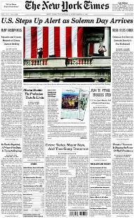
2000
In November The New York Times Book Review includes a review of four graphic novels
Eggers, D. (2000, November 26). After Wham! Pow! Shazam! The New York Times Book Review, pp. 10–11.
The! Greatest!
of! Marlys!
By Lynda Barry.
Illustrated. Unpaged. Seattle:
Sasquatch Books. Paper, $15.95.
JULIUS KNIPL, REAL
ESTATE PHOTOGRAPHER
The Beauty Supply District.
By Ben Katchor.
Illustrated. 108 pp. New York:
Pantheon Books. $22.
David Boring
By Daniel Clowes.
Illustrated. 116 pp. New York:
Pantheon Books. $24.95.
Jimmy Corrigan
The Smartest Kid on Earth.
By Chris Ware.
Illustrated. Unpaged. New York:
Pantheon Books. $27.50.

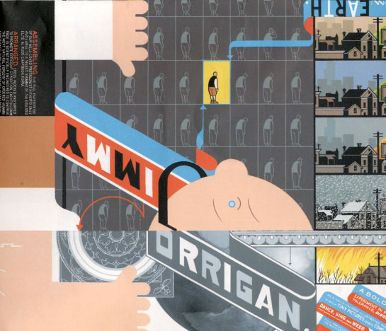
Awarded since 1965 by the Guardian newspaper, the prize is worth £10,000 to the winner. In 1965 the prize money was 200 guineas (£220) and was awarded to a work of fiction by British or Commonwealth writer and published in the UK. The shortlist is announced in November each year and the winner in December. The selection is made by a panel of critics and writers, chaired by the literary editor of the Guardian. This is the oldest and best-established of the awards sponsored by a newspaper. Although sponsorship by one newspaper has a somewhat negative effect on publicity since other newspapers are less willing to publicize the winner.
A "wacky idea" which began life as newspaper cartoon strip last night became the first graphic novel to win a big British literary award. Jimmy Corrigan, or The Smartest Kid On Earth - a tragi-comic tale of familial misery set in the American midwest spanning four generations of the downtrodden Corrigan clan - has won the Guardian First Book Award for Chris Ware, the second American to take the prize in its three years.
Jimmy Corrigan, the Smartest Kid on Earth is a widely-acclaimed graphic novel by Chris Ware, published in 2000. The story, previously serialized in the pages of Ware's comic book Acme Novelty Library (and, previous to that, in the alternative Chicago weekly New City), is about Jimmy Corrigan, a meek and lonely man in his mid-thirties who meets his father for the first time in a Michigan town over Thanksgiving weekend. Jimmy is an awkward and cheerless character with an overbearing mother and a very limited social life. Jimmy attempts to escape his unhappiness via an active imagination that sometimes gets him into awkward situations.
The story explores themes of discontent and alienation, especially within families. Elements of the novel seem autobiographical, particularly in passages about Jimmy's estranged relationship with his father (Ware only met his father once in adulthood). However, it should not be read as an account of Ware's personal life. There are also many flashback scenes, including a substantial narrative set in the Chicago World's Columbian Exposition of 1893. The 1893 sections follow Jimmy's grandfather as a lonely little boy and his difficult relationship with an abusive father (Jimmy's great grandfather).

http://www.ala.org/ala/yalsa/teenreading/trw/trw2002/trw2002.htm
The American Library Association's 2002 Teen Read Week theme was Getting Graphic @ Your Library
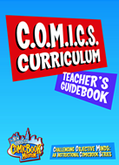
http://www.nyccomicbookmuseum.org/education/education.htm
Comics in the Classroom
What is it about comic books that draws kids to them? There’s the story—they can’t wait to find out what happens next. And the action-packed illustrations help. But there’s also a "clandestine nature that reading comic books is something that they are getting away with" that makes the medium appealing, says Dan Tandarich, education chair on the board of trustees for the New York City Comic Book Museum.
The power of comics in the classroom is something Tandarich, a lifelong comics fan, has experienced firsthand. A fifth-grade teacher at Brooklyn’s P.S. 124, he recently designed an eight-lesson curriculum program to help boost kids’ reading, writing, listening and speaking skills through comics. Tandarich says he "hopes to reach … students who struggle with reading or who show a disinterest in reading, as well as all those who already know what a great thing it is to be entertained by picking up something you enjoy reading."
Despite the stigma of comic books being "junk" reading, hundreds of teachers and librarians have shown an interest in the curriculum, he says. And when he submitted the program as an extracurricular club idea for his own school, he got the thumbs up from his principal.
"Challenging Objective Minds: an Instructional Comicbook Series" was created for grades 5-10 and has currently been piloted in 10 schools. Others can preview 10 C.O.M.I.C.S. pages online at www.nyccomicbookmuseum.org/
Private.htm, or purchase the whole program, which includes a comic book for each student, for $50 (plus $10 s/h).
Tandarich suggests that teachers interested in the medium also plan a trek to their local comic book store to search for materials a specific class would enjoy.
While it may be too early to call it a curriculum trend, including comics in the classroom has been a topic of interest for other educators as well. At a recent panel discussion sponsored by Organized Readers of Comics Associated in Pittsburgh, teacher Mary Stronach of Whitesboro (N.Y.) High School introduced a sample comic book curriculum she’s developing to help teachers integrate comics into English, social studies and creative arts classes throughout K-12.
In 2002, the New York City Comic Book Museum released C.O.M.I.C.S., an eight-lesson curriculum for K-12 students teaching the reading and creation of comics. Dozens of schools across the nation ordered the curriculum before it was even complete.
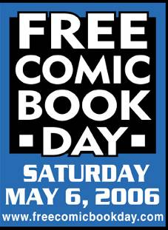
http://www.freecomicbookday.com/
1. What is "Free Comic Book Day?"
As the name implies, Free Comic Book Day is a single day when participating comic book shops across North America and around the world are giving away comic books absolutely free to anyone who comes into their stores.
2. When is Free Comic Book Day?
Free Comic Book Day will take place on May 5, 2007 .
3. Are they really free?
Yep!
4. Is every comic book store in the world doing this?
If you're asking about convenience stores with a spinner rack of comics in a corner somewhere, the answer is no. This event celebrates the independent comic book specialty stores, thousands of which exist in North America alone. Each one is unique in its community, with a style and personality all its own, and each one carries a full line of comics, graphic novels, and related products.
While we hope every one of these stores will take part, each store will determine on its own whether or not to participate.

The History of Graphic Novels
What are graphic novels? – Truths and Fictions[DR1]
History of Filmmaking and storyboarding
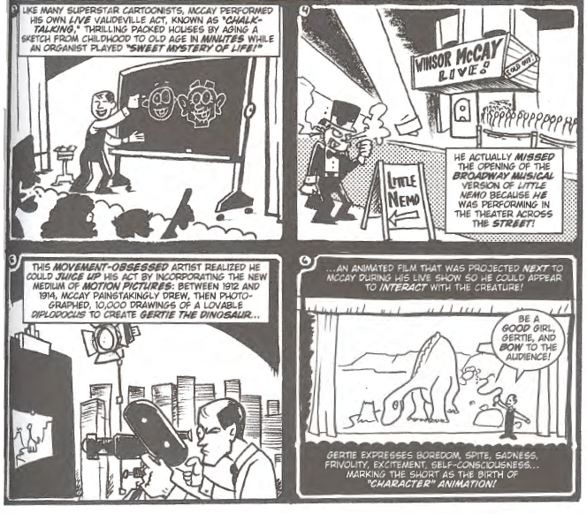
Sequential art showed up in the early motion pictures as comic shorts, but they were very choppy and hard to follow.
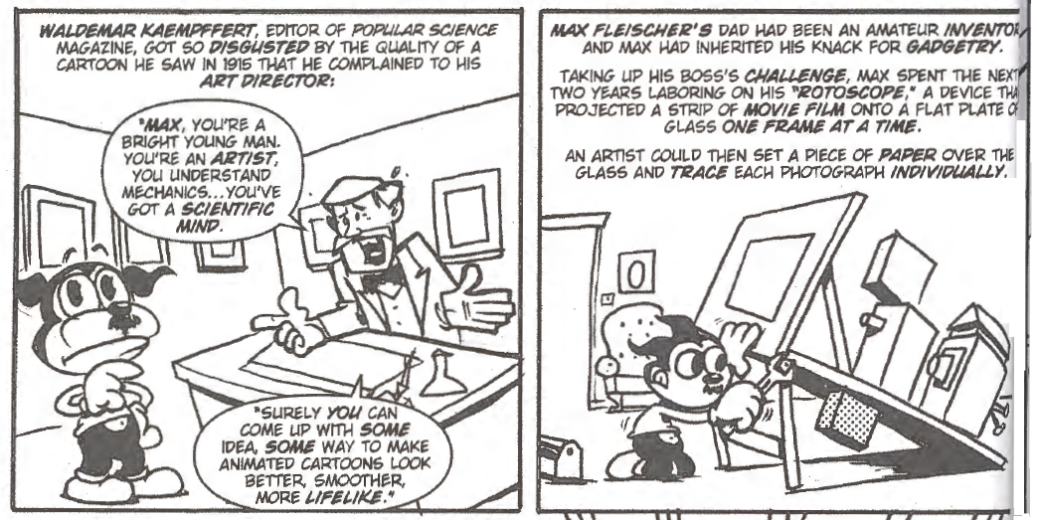
With the improved images
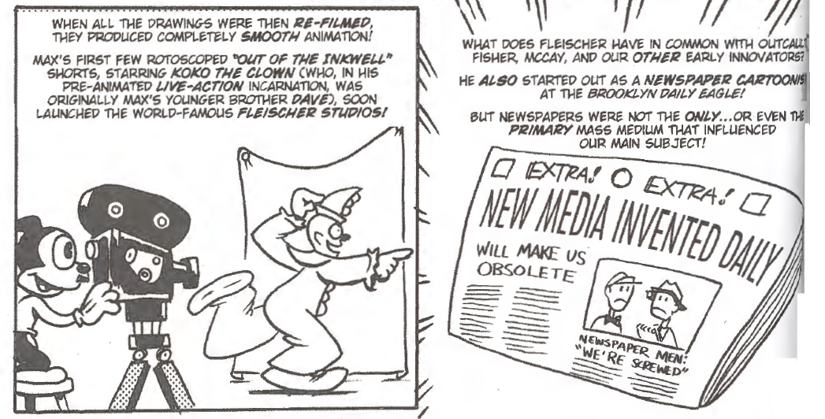
Eventually, the fluid animations became the moving cartoons we know as Popeye the Sailor.
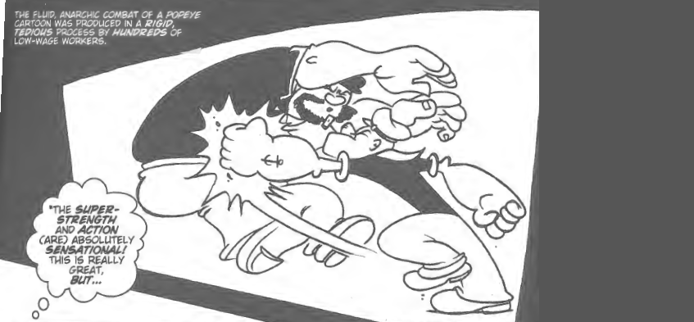
While the short cartoon was popular, people thought that they could not match the live films being made because no one would be able to relate to animated characters.
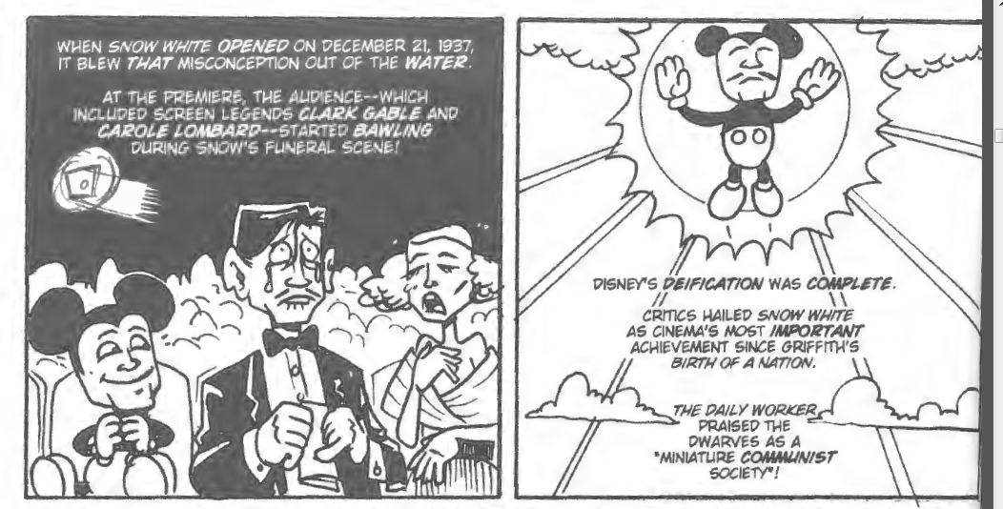
………………………
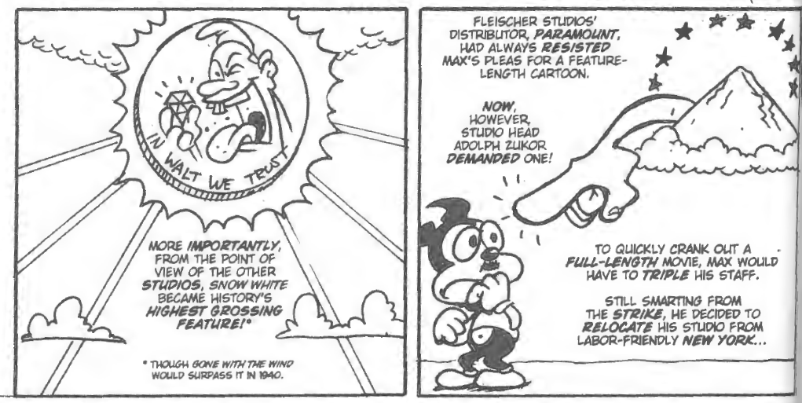
Synthesis for the current day – Why this is a critical skill for our students moving forward
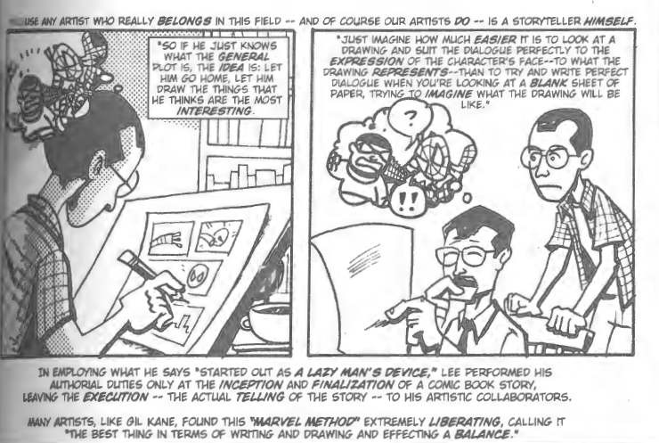
……………
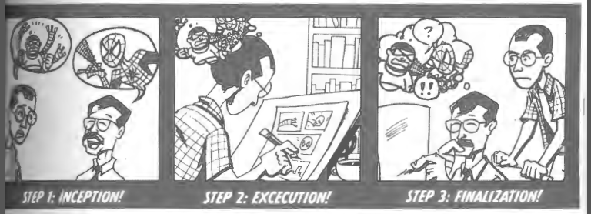
//
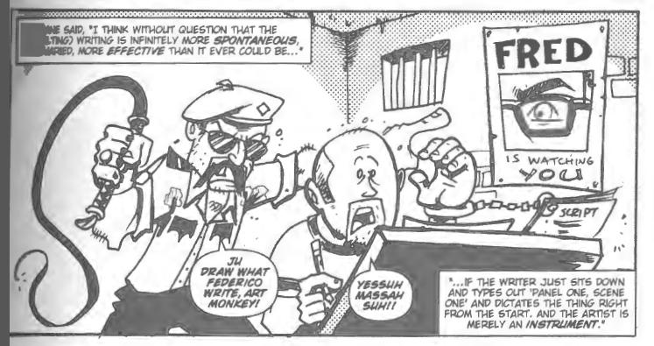
[DR1]Good
http://www.homepages.dsu.edu/mgeary/comics/Comics-VisualRevolution.pdf

Today, we have animated movie egenerator that can create animated video based strictly of the conventions of a script. While the voices are still somewhat mechanical and stilted, XtraNormal.com does allow you to create movies from text alone. As the site says, “If you can type, it can talk.” Collaborative Planning was a especially engaging video, showing the frustrations of a teacher trying to teach her students verse structure.


